Go to the Interfolio email shared by your Unit Administrator, click the link.
This will bring you to a page where you can view your review. Please note the due date at the top left.
Once you have read through the review, you can submit your document indicating your acknowledgement of the review by clicking on “Send Response” and uploading your word document (*see note below regarding rebuttals).
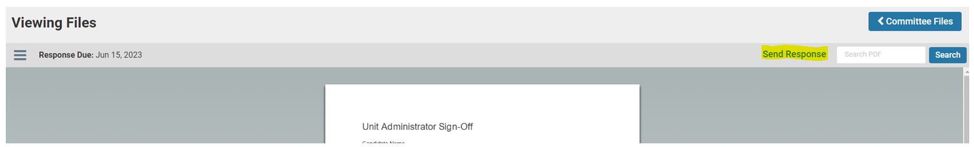

As a reminder, your response should include the acknowledgement below:
I CERTIFY THAT I HAVE READ THIS DOCUMENT AND HAVE DISCUSSED IT WITH THE EVALUATOR. MY SIGNATURE CONNOTES NEITHER AGREEMENT NOR DISAGREEMENT WITH THE RATINGS AND COMMENTS HEREON. I UNDERSTAND THAT I MAY ALSO DISCUSS THIS DOCUMENT WITH OTHER MEMBERS OF THE UNIVERSITY’S ADMINISTRATION.
*If you intend to file a rebuttal to your review, please contact Courtney Berwick (cberwic@ju.edu) and request a rebuttal submission link prior to uploading your acknowledgement response. If you are submitting a rebuttal, you will first submit the rebuttal using the link provided by Courtney and then submit the acknowledgement above which does not connote agreement nor disagreement.

